Issue: TM1 Web is freezing up for users in production.

The tm1 web application server details below.

Users are effected due to freezing up of tm1 web pages during critical budget month end.

We are ended up by restarting the web services most of the time.

Can you please advise to resolve this issue and how come we make the consumption of memory should not reach the threshold?

**10.67.10.16**

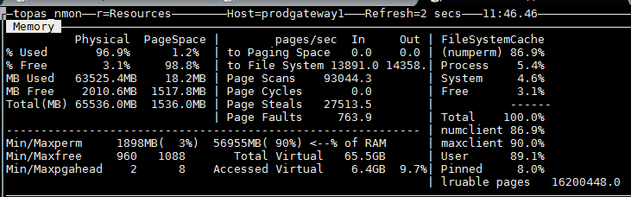

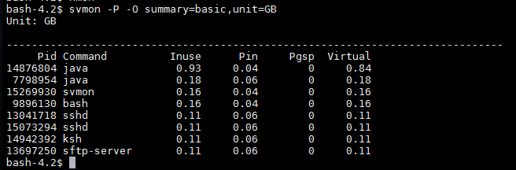

**10.67.10.17**

