Task Manager:

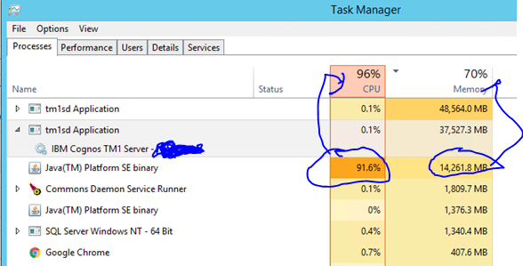

**TM1 Server Log:** (correct sign log below) Which cause Java CPU Spike

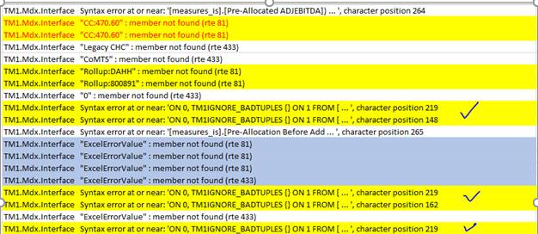

**Verbosec Log file:**

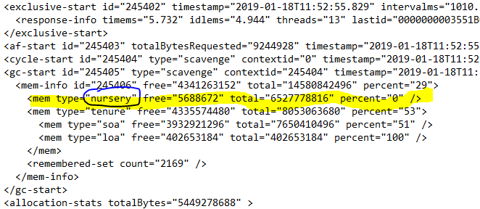

**Jvm.Option**

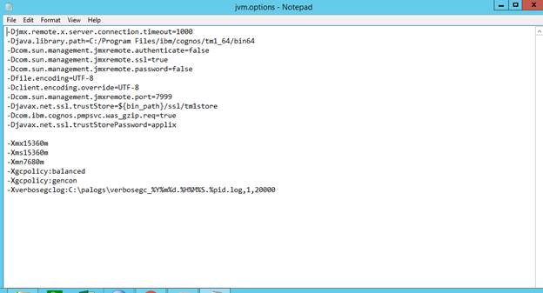

Yesterday, we update jvm.option file with having only -xgcpolicy:gencon and restarted java services.