Scenario C - Process 1  BASELINE CODE CREATES DIMESNION WITH DATES & ATTRIBUTES  Expected Output | 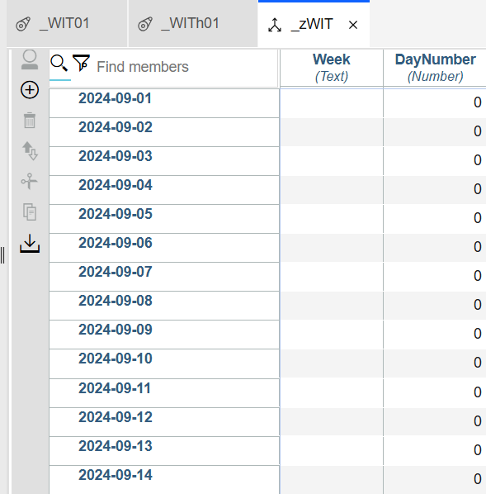
DimName = '_zWIT';
HierName = DimName;
cAttr1 = 'DayNumber';
cAttr2 = 'Week';

IF(DimensionExists(DimName)=1);
DimensionDestroy(DimName);
DimensionCreate(DimName);
ELSE;
DimensionCreate(DimName);
ENDIF;

AttrInsert(DimName, '', cAttr1, 'N');
AttrInsert(DimName, '', cAttr2, 'S');

cDayStart = '2024-09-01';
cDayEnd = '2024-09-14';

sDim = EXPAND('%DimName%:%HierName%');

nEle = DAYNO(cDayStart);
WHILE(1 = 1);
sEle = TIMST(nEle, '\Y-\m-\d');

DIMENSIONELEMENTINSERT(sDim, '', sEle, 'N');

IF(sEle @= cDayEnd);
BREAK;
ELSE;
nEle = nEle + 1;
ENDIF;
END;

Scenario C - Process 2  BASELINE CODE - CREATES Consolidation & Adds Attribute Elements  Expected Output | 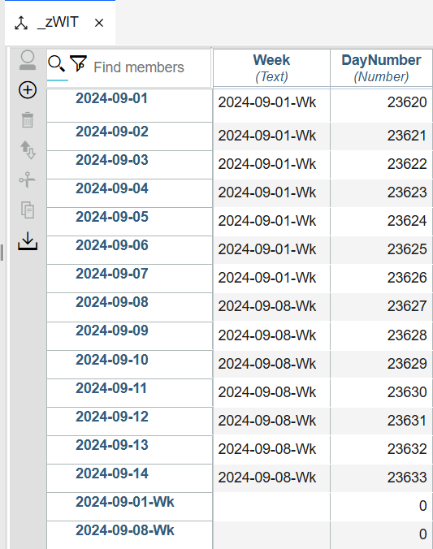
DimName = '_zWIT';
HierName = '_zWIT';
ElCnt = DimSiz(DimName);
nAttr1 = 'DayNumber';
sAttr1 = 'Week';
sElm = 1;

While(sElm <= ElCnt);
ElNm = ELEMENTNAME(DimName,HierName,sElm);
WkDt = TIMST(DAYNO(ElNm),'\Y-\m-\d');
DayNum = DAYNO(WkDt);
nOut = MOD(DayNum,7);
IF(nOut = 2);
Con = WkDt | '-Wk';
DimensionElementInsert(DimName,'',Con,'S');
ENDIF;

ATTRPUTN(DayNum,DimName,ElNm,nAttr1);
ATTRPUTS(Con,DimName,ElNm,sAttr1);
sElm = sElm +1 ;
END;

Scenario C - Process 3  BASELINE CODE - CREATES Consolidation & Adds Attribute Elements  Expected Output | 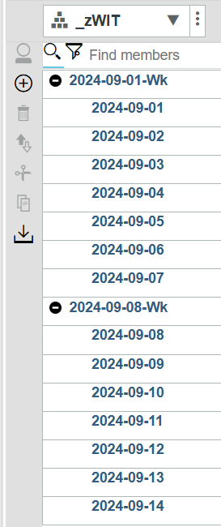
### GLOBAL VARABLES
DimName = '_zWIT';
HieNm = '_zWIT';
ElmCnt = DimSiz(DimName);
sAttr1 = 'Week';

ITElm = 1;

While(ITElm <= ElmCnt);

ElNm = ELEMENTNAME(DimName,HieNm,ITElm);
cAttr1 = AttrSL(DimName, ElNm, sAttr1);
ASCIIOUTPUT('c:\tm1\build\znote\wti3.txt', cAttr1 |' - ' | ElNm);
DimensionElementComponentAdd(DimName, cAttr1,ElNm, 1);
ITElm = ITElm +1;
IF(LONG(ElementName(DimName,HieNm, ITElm))>10);
BREAK;
ENDIF;
END;

