Scenario H - Process 1  HIERARCHY CODE - CREATES DIMESNION WITH DATES & ATTRIBUTES  Output As Expected | Scenario C - Process 1  BASELINE CODE CREATES DIMESNION WITH DATES & ATTRIBUTES  Expected Output
DimName = '_zzMasterTime';  HierName = 'Week';  cAttr1 = 'DayNumber';  cAttr2 = 'Week';  IF(DimensionExists(DimName)=1);  DimensionDestroy(DimName);  DimensionCreate(DimName);  ELSE;  DimensionCreate(DimName);  ENDIF;  sHier = HIERARCHYCREATE(DimName,HierName);  AttrInsert(DimName, '', cAttr1, 'N');  AttrInsert(DimName, '', cAttr2, 'S');  cDayStart = '2024-09-01';  cDayEnd = '2024-09-14';  nEle = DAYNO(cDayStart);  WHILE(1 = 1);  sEle = TIMST(nEle, '\Y-\m-\d');  HIERARCHYELEMENTINSERT(DimName,HierName, '', sEle, 'N');  IF(sEle @= cDayEnd);  BREAK;  ELSE;  nEle = nEle + 1;  ENDIF;  END; | DimName = '_zWIT';  HierName = DimName;  cAttr1 = 'DayNumber';  cAttr2 = 'Week';  IF(DimensionExists(DimName)=1);  DimensionDestroy(DimName);  DimensionCreate(DimName);  ELSE;  DimensionCreate(DimName);  ENDIF;  AttrInsert(DimName, '', cAttr1, 'N');  AttrInsert(DimName, '', cAttr2, 'S');  cDayStart = '2024-09-01';  cDayEnd = '2024-09-14';  sDim = EXPAND('%DimName%:%HierName%');  nEle = DAYNO(cDayStart);  WHILE(1 = 1);  sEle = TIMST(nEle, '\Y-\m-\d');  DIMENSIONELEMENTINSERT(sDim, '', sEle, 'N');  IF(sEle @= cDayEnd);  BREAK;  ELSE;  nEle = nEle + 1;  ENDIF;  END;

Scenario H - Process 1  Output As Expected | Scenario C - Process 1  Expected OutPut
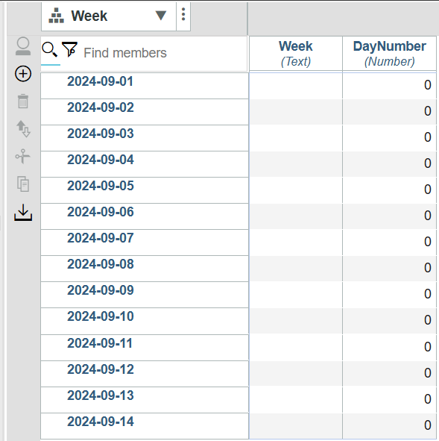 | 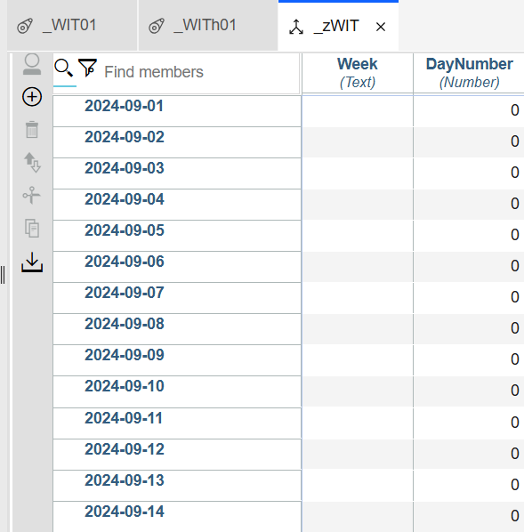

Scenario H - Process 2  HIERARCHY CODE - CREATES Consolidation & Adds Attribute Elements  Output Not As Expected - FAILED | Scenario C - Process 2  BASELINE CODE - CREATES Consolidation & Adds Attribute Elements  Expected Output
DimName = '_zzMasterTime';  HierName = 'Week';  ElCnt = DimSiz(DimName);  nAttr1 = 'DayNumber';  sAttr1 = 'Week';  sElm = 1;  While(sElm <= ElCnt);  ElNm = ELEMENTNAME(DimName,HierName,sElm);  WkDt = TIMST(DAYNO(ElNm),'\Y-\m-\d');  DayNum = DAYNO(WkDt);  nOut = MOD(DayNum,7);  IF(nOut = 2);  Con = WkDt | '-Wk';  HierarchyElementInsert(DimName,HierName,'',Con,'S');  ENDIF;  sDim = EXPAND('%DimName%:%HierName%');  ATTRPUTN(DayNum,sDim,ElNm,nAttr1);  ATTRPUTS(Con,sDim,ElNm,sAttr1);  sElm = sElm +1 ;  END; | DimName = '_zWIT';  HierName = '_zWIT';  ElCnt = DimSiz(DimName);  nAttr1 = 'DayNumber';  sAttr1 = 'Week';  sElm = 1;  While(sElm <= ElCnt);  ElNm = ELEMENTNAME(DimName,HierName,sElm);  WkDt = TIMST(DAYNO(ElNm),'\Y-\m-\d');  DayNum = DAYNO(WkDt);  nOut = MOD(DayNum,7);  IF(nOut = 2);  Con = WkDt | '-Wk';  DimensionElementInsert(DimName,'',Con,'S');  ENDIF;  ATTRPUTN(DayNum,DimName,ElNm,nAttr1);  ATTRPUTS(Con,DimName,ElNm,sAttr1);  sElm = sElm +1 ;  END;

Scenario H - Process 2  Output - Failed | Scenario C - Process 2  Output - Expected
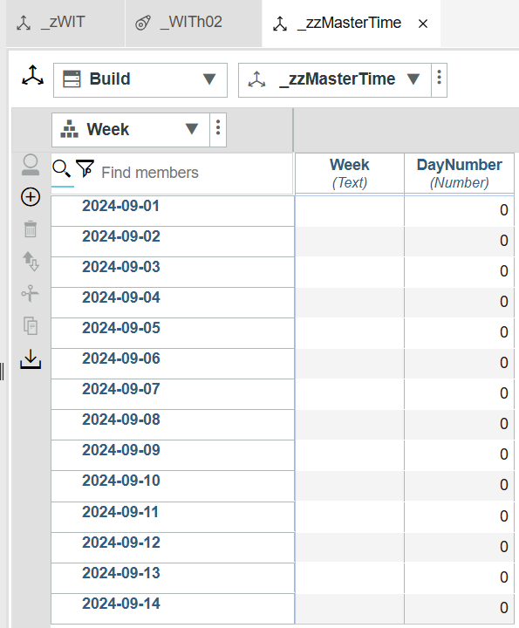  Wk Consolidations are not included in Scenario H – Process 2. | 

