Hello All -
Context - I am doing a deep dive into Hierarchies. I'm using a test date range in a dimension (9/1/2024 - 9/14/2024) to create two alternative hierarchies. The Parent dimension are the dates in sequential order with a total of all dates at the top. The alternative hierarchies ("Alt Hier") are a Week and ITD hierarchy. I created the basic dimension for the two Alt Hier to test the build code. It worked perfectly. Next I converted the Week dimension TI process to create a alternative hierarchy.
Problem - The empty Hierarchy is created; however, the "week" consolidation elements are not created nor are the attributes added to the dimension.
I am using on Premise PAW 2.0.77.1 and TM1-AW64-ML-RTM-11.0.0.28-0.
Below I have provided the expected output, the actual output and the two TI processes used.
Thank you in advance for any guidance.

WITh01 – CREATES DIMESNION WITH WEEK CONSOLIDATIONS HIERARCY | WIT01 – CREATES DIMENSION WITH WEEK CONSOLIDATION
DimName = '_zzMasterTime';  HierName = 'Week';  cAttr1 = 'DayNumber';  cAttr2 = 'Week';  IF(DimensionExists(DimName)=1);  DimensionDestroy(DimName);  DimensionCreate(DimName);  ELSE;  DimensionCreate(DimName);  ENDIF;  sHier = HIERARCHYCREATE(DimName,HierName);  AttrInsert(DimName, '', cAttr1, 'N');  AttrInsert(DimName, '', cAttr2, 'S');  cDayStart = '2024-09-01';  cDayEnd = '2024-09-14';  nEle = DAYNO(cDayStart);  WHILE(1 = 1);  sEle = TIMST(nEle, '\Y-\m-\d');  HIERARCHYELEMENTINSERT(DimName,HierName, '', sEle, 'N');  IF(sEle @= cDayEnd);  BREAK;  ELSE;  nEle = nEle + 1;  ENDIF;  END; | DimName = '_zWIT';  HierName = DimName;  cAttr1 = 'DayNumber';  cAttr2 = 'Week';  IF(DimensionExists(DimName)=1);  DimensionDestroy(DimName);  DimensionCreate(DimName);  ELSE;  DimensionCreate(DimName);  ENDIF;  AttrInsert(DimName, '', cAttr1, 'N');  AttrInsert(DimName, '', cAttr2, 'S');  cDayStart = '2024-09-01';  cDayEnd = '2024-09-14';  sDim = EXPAND('%DimName%:%HierName%');  nEle = DAYNO(cDayStart);  WHILE(1 = 1);  sEle = TIMST(nEle, '\Y-\m-\d');  DIMENSIONELEMENTINSERT(sDim, '', sEle, 'N');  IF(sEle @= cDayEnd);  BREAK;  ELSE;  nEle = nEle + 1;  ENDIF;  END;
Out Put | OutPut
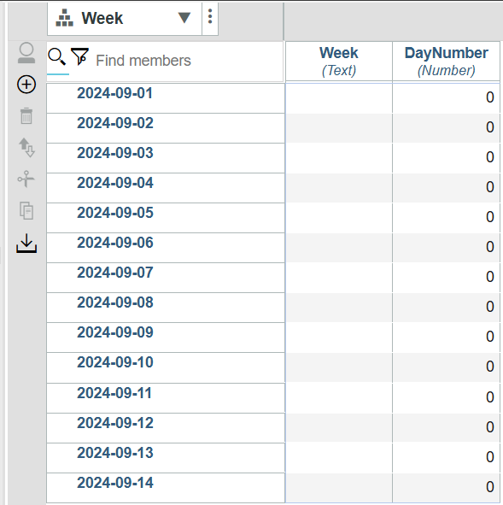 | 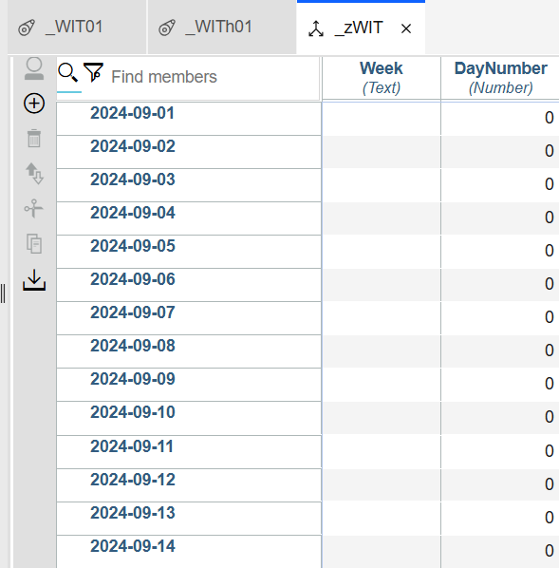

WITh02 | WIT02
DimName = '_zzMasterTime';  HierName = 'Week';  ElCnt = DimSiz(DimName);  nAttr1 = 'DayNumber';  sAttr1 = 'Week';  sElm = 1;  While(sElm <= ElCnt);  ElNm = ELEMENTNAME(DimName,HierName,sElm);  WkDt = TIMST(DAYNO(ElNm),'\Y-\m-\d');  DayNum = DAYNO(WkDt);  nOut = MOD(DayNum,7);  IF(nOut = 2);  Con = WkDt | '-Wk';  HierarchyElementInsert(DimName,HierName,'',Con,'S');  ENDIF;  sDim = EXPAND('%DimName%:%HierName%');  ATTRPUTN(DayNum,sDim,ElNm,nAttr1);  ATTRPUTS(Con,sDim,ElNm,sAttr1);  sElm = sElm +1 ;  END; | DimName = '_zWIT';  HierName = '_zWIT';  ElCnt = DimSiz(DimName);  nAttr1 = 'DayNumber';  sAttr1 = 'Week';  sElm = 1;  While(sElm <= ElCnt);  ElNm = ELEMENTNAME(DimName,HierName,sElm);  WkDt = TIMST(DAYNO(ElNm),'\Y-\m-\d');  DayNum = DAYNO(WkDt);  nOut = MOD(DayNum,7);  IF(nOut = 2);  Con = WkDt | '-Wk';  DimensionElementInsert(DimName,'',Con,'S');  ENDIF;  ATTRPUTN(DayNum,DimName,ElNm,nAttr1);  ATTRPUTS(Con,DimName,ElNm,sAttr1);  sElm = sElm +1 ;  END;
Output | Output
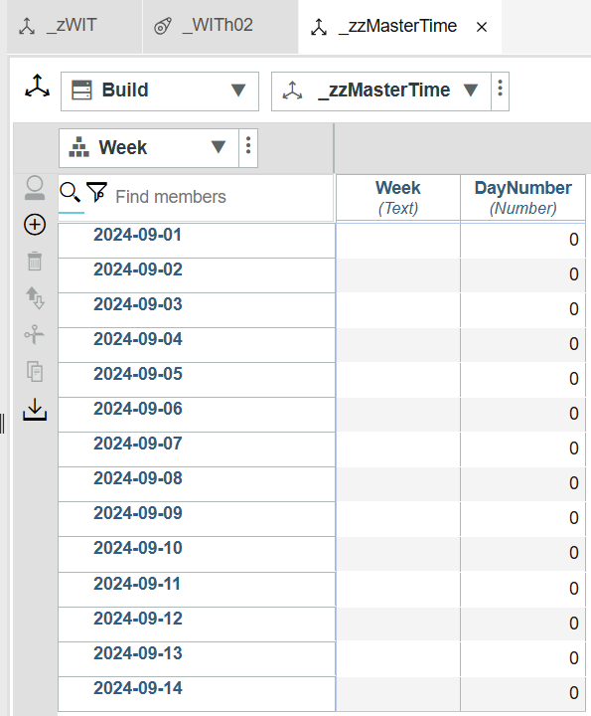 | 

