Missing TM1 Data – Steps to reproduce (SData)
TM1 Version: 10.2.2 FP5 (have seen this also on a client on 10.2.2 FP6 & 10.2.2 FP6 IF1)
- Turn persistent feeders on in tm1s.cfg
- In Sales Cube, create a new account (e.g. Test1), and create a feeder which feeds into this new account (e.g. per highlighted line below):
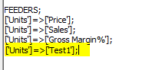
- Enter some values into the Sales Cube against this new account:
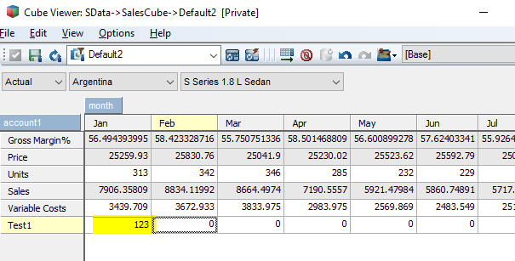
- Perform SaveDataAll, and shutdown the server.
- Restart the server (no changes to any config) Previously entered value under Jan is gone
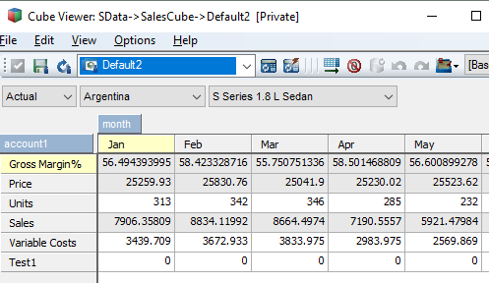

Further Testing:
- Enter a value in a different cell:
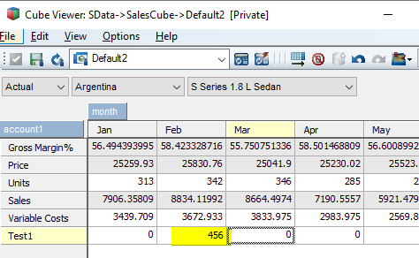
- SaveDataAll, shutdown and restart with PersistentFeeders OFF values for Feb retained
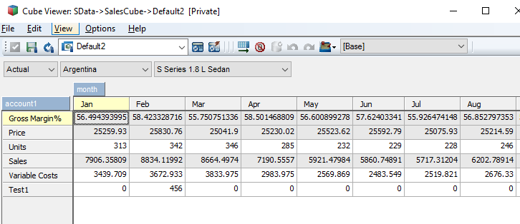
- Enter values back onto first cell:
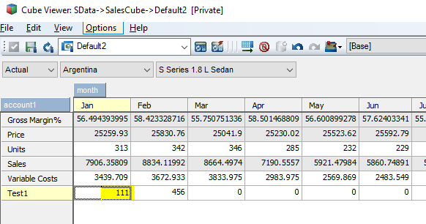

- Restart TM1 service without changing any config Values retained when persistentfeeders is OFF
- Enter values in another cell:
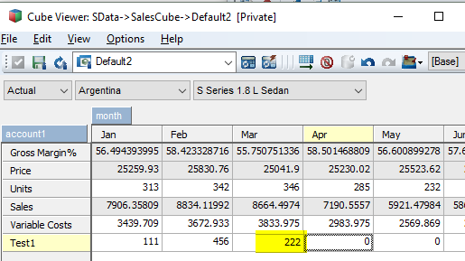
- Savedataall, shutdown and restart with persistent feeders ON all values retained when feeders are recalculated.
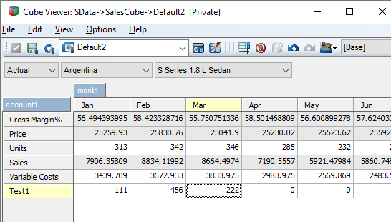
- Update a previous entered values, also enter a value on a new cell:
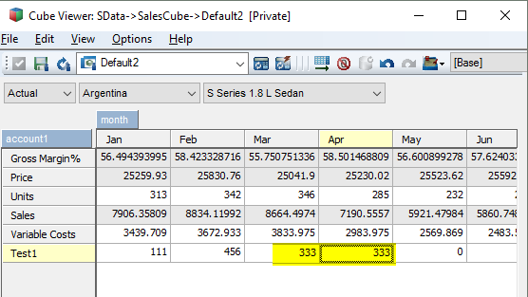

- Restart TM1 service without changing any config previously entered cell stayed but the new cell data is missing
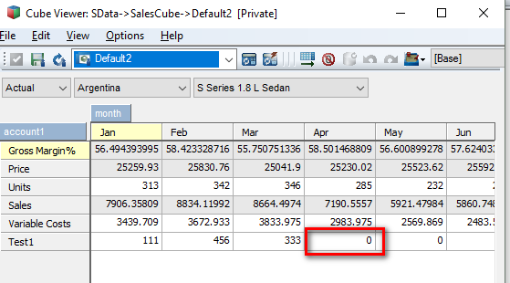

- Savedataall, without changing any data, restart the TM1 service with PersistentFeeders OFF The previously missing data appeared again.


