Hi,

User trying to filter and select the subsets and he could select the leaf level element and the value are displaying in the report ,but when he select the consolidated element values are not displaying and the element name not displaying only showing error.
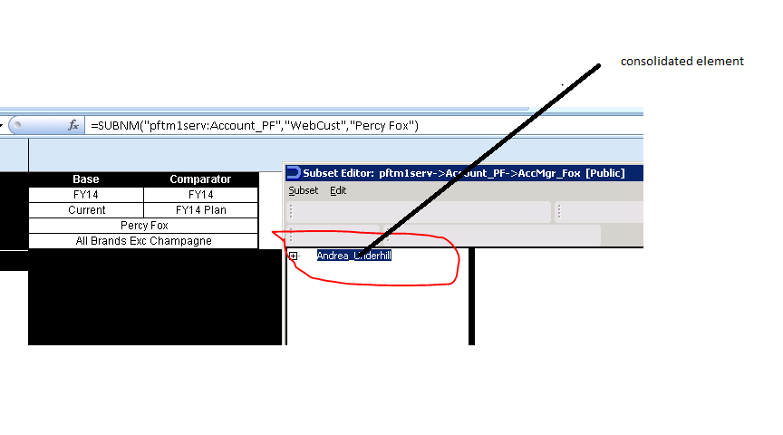
When I select consolidated element showing like below
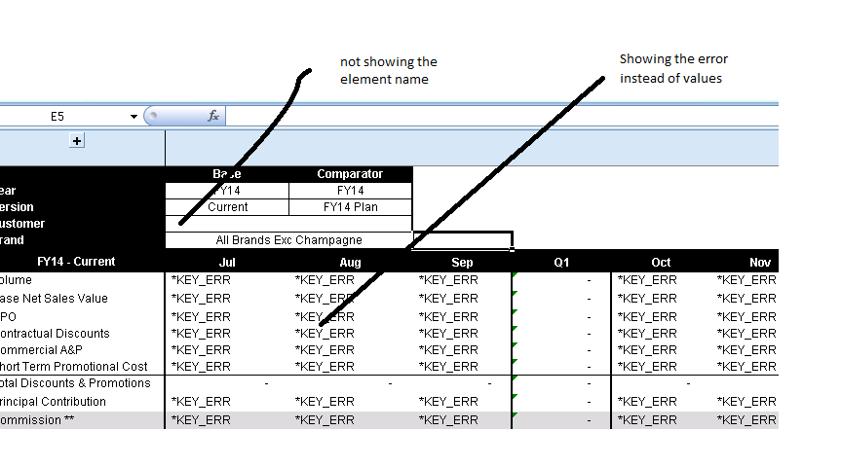

When I select leaf level element showing the element name coming the values

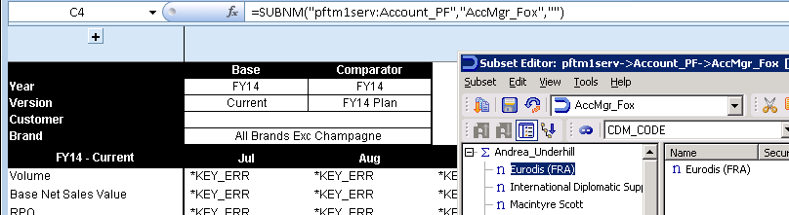

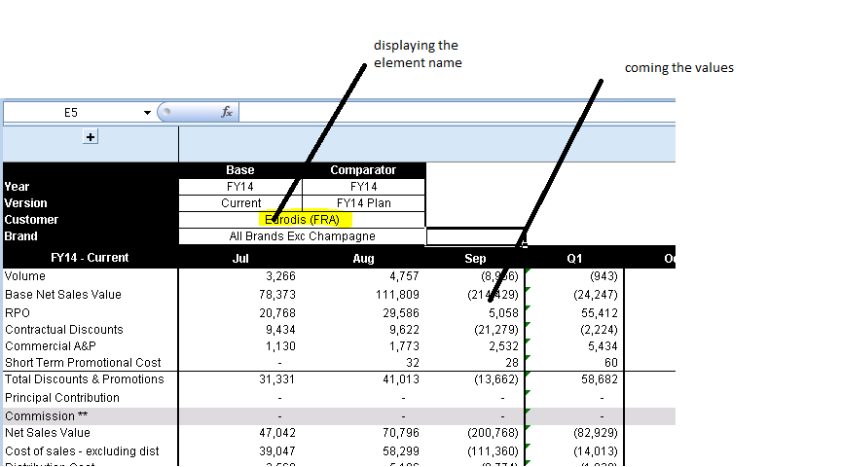

When I tried from TM1 web I could select consolidated and leaf level elements



