Hi,

I am facing one issue with Excel report in TM1
User trying to filter and select the subsets and he could select the leaf level element ,the value are displaying in the report ,but when he select the consolidated element ,it is not displaying the element name and the values are not generating only showing error.
using the following function
=SUBNM("pftm1serv:Account_PF","AccMgr_Fox","")
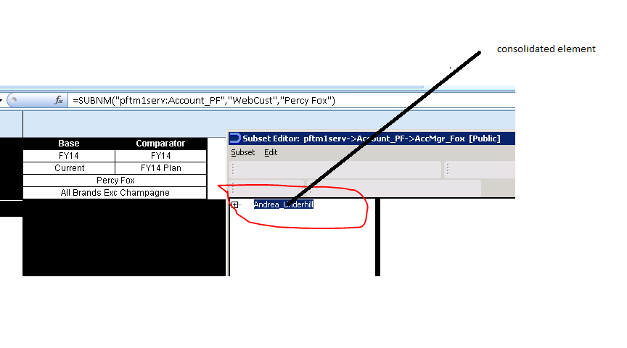
When I select consolidated element showing like below
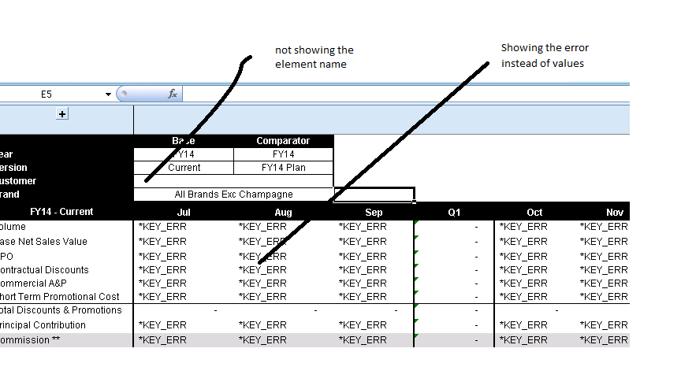

When I select leaf level element showing the element name coming the values

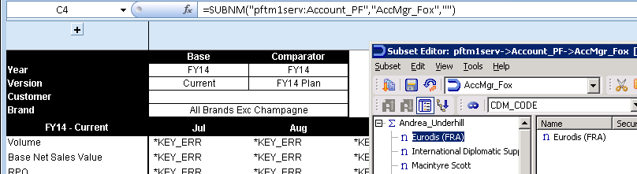

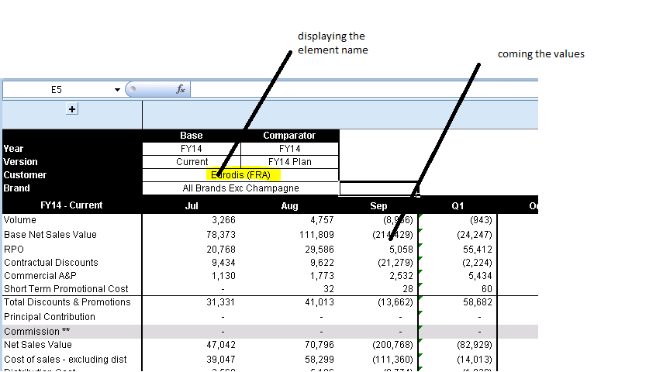

When I tried from TM1 web I could select consolidated and leaf level elements



