Here is a screenshot of the “Account” cube on the “Common” server. It is two dimensional with the “Account” dimension having a hierarchy with ranges as shown below. The “Account” dimension has four attributes, which are shown below in gray (Account Description, Account Group Prefix, Account Group, and Status). The additional columns are manually populated and are simply different mappings. This will come into play later.
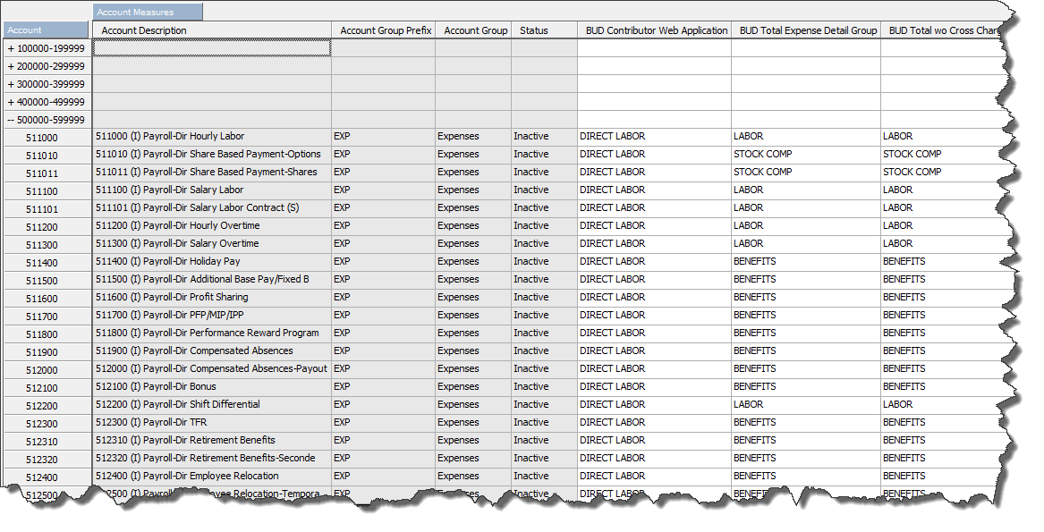

Things to do:
- Create a “Publish” cube view
- Create TI Process
- Add Attributes to Dimension
- Adding Attributes from a Dimension and Populating from a Cube
- Have table created on SQL server
- Finish TI Process

Create a “Publish” cube view
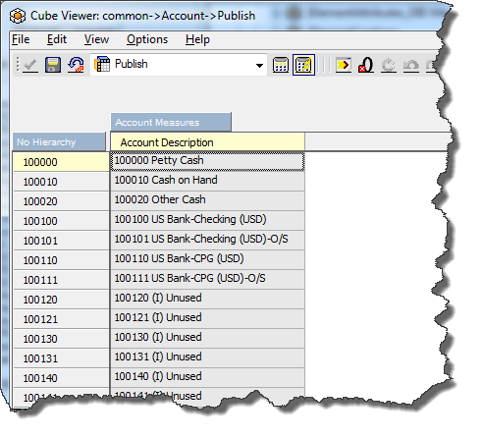
You can’t have hierarchies in the view of the cube you are publishing. Thus, created a subset of the “Account” dimension that only had level 0 items (no hierarchy).

Then, also created a subset of the “Account Measures” dimension that only has one item in it (the first). So, in this example, will leave only “Account Description” in that subset.

Result is:
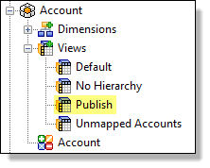

At this point, this probably seems odd, but hang in there and closely follow along and it will all make sense in the end.
If you do not hide all columns but one, when it’s published (or exported to an ASCII file), you will have duplicate records. In this example, if the view as like this (meaning, four columns in the view):
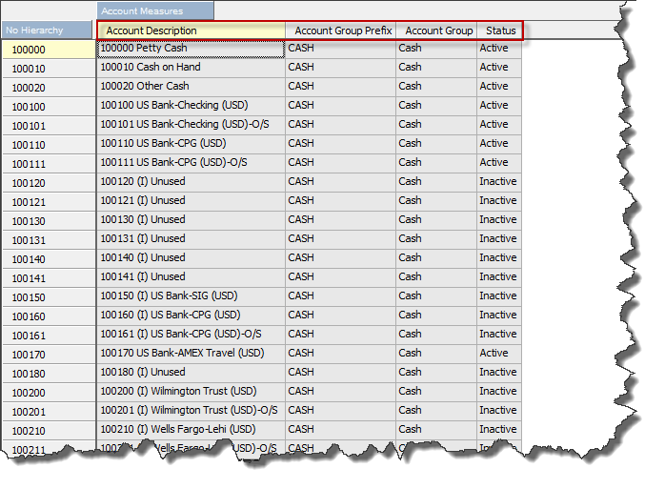

When it’s published to the SQL table, it will look like this (notice each account is duplicated 4 times – one time for each column):
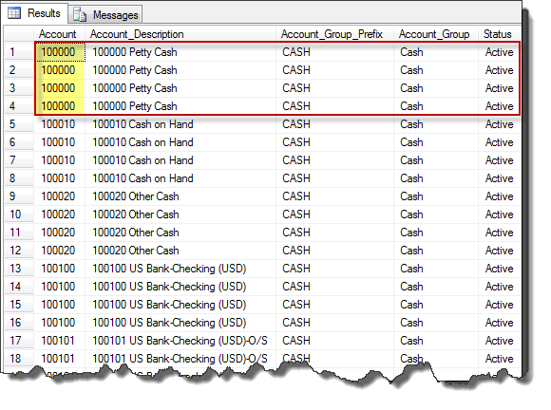

Therefore, make sure to create a cube view that is called “Publish” (so it is known to all developers that this particular view is related to a publish) that has no hierarchy and only has one column shown.

Create TI Process

- On the Data Source tab, click on IBM Cognos TM1 button and choose Cube View in the drop down
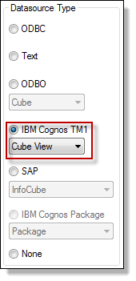

- Click on the Browse… button

- Choose your cube name on the left and the “Publish” view you created on the right, click OK
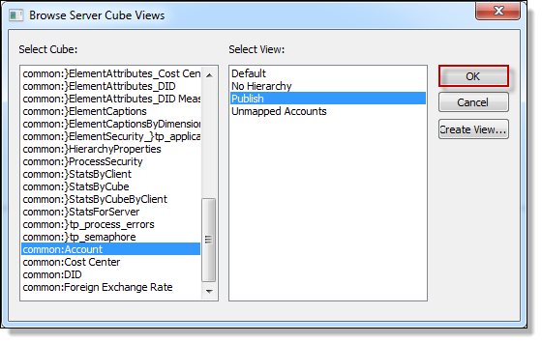

- Click Preview button
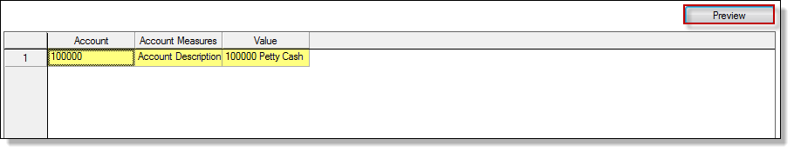

This is only a preview. However, notice that the three columns that are showing above are “Account,” “Account Measure,” and “Value” – this is not how we want to publish. If it published this way, it would produce a line for each column header and Account would be duplicated the number of column headers you have. We want one individual line for each account, not multiple. This will be taken care of on the Variables tab.

- Click on the Variables tab and it will look something like this:
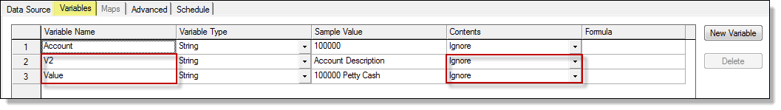

Remember from step 4, we do not want to publish “Account Measures” and “Value?” “Account Measures” is listed above as V2 because it is two words and then you see “Value.” In the Contents column, we want to make sure these two are ignored because we will be adding New Variables in which to publish.

- “Account” is the key dimension here, so we want to Publish it. Thus, change it from Ignore to Other. Anything that will be published needs to be “Other” in the Contents column.
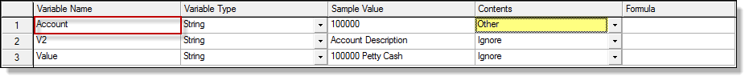

- Remember our cube view? We could only have one column listed or it would duplicate records in the publish? Those columns are merely hidden and are attributes in our “Account” dimension. Therefore, we are going to create “New Variables” and then create formulas to pull those attributes into our publish as “variables.” If your key dimension (in this case, Account) doesn’t have any attributes, you will need to create them before you can do this step (see the next section called “Adding Attributes from a Dimension and Populating from a Cube”)

Click New Variable button

- The four attributes in our “Account” dimension are “Account Description,” “Account Group,” “Account Group Prefix,” and “Status” – thus, we will add 4 variables with those same names but minus spaces and with a “v” in front of each name. Also, in the Contents column, change to “Other”
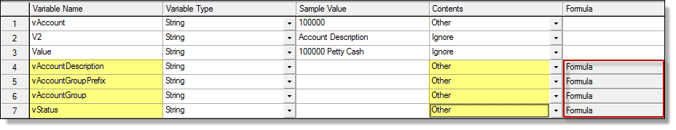

- Now, we have to add Formula’s for each of our new variables because we have to tell TM1 to go get the attribute from the “Account” dimension. For each, click on Formula. A box will appear that looks like this:

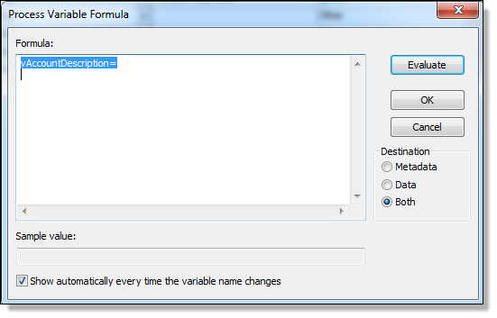
Do not delete what is highlighted. You will be adding a formula to the right of this.

Dimension name where the attributes are coming from
The variable name you are adding the attribute to
If attribute is a string, then ATTRS. If a number, then ATTRN
The attribute name as seen in the dimension

vAccountDescription=ATTRS('Account',vAccount,'Account Description');

This is the formula that you’ll edit.
This is the variable name from the Variable Name column – don’t change.

- The “Account” dimension in the “Account” cube, has four attributes. Those attributes are now pulled into our process as variables. However, there are additional attributes that are found in the “Account” cube – in the data section of the cube. Those are the various mappings for the different business areas for each account. We need to publish those as well. However, those aren’t attributes in our “Account” dimension (yet) so we have to make them as attributes first and then we can continue as shown above.

Add Attributes to Dimension

Before we can populate our attributes from our cube, we need to add them to our Account dimension first. At this point, all we have are four attributes in our “Account” dimension; Account Description, Account Group Prefix, Account Group, and Status. However, we want to publish all the columns in our cube – the additional columns. Therefore, those have to be added to the “Account” dimension so we can then populate the attributes from our cube.

- In Server Explorer, find the dimension you need to add attributes to. In this example, it’s the “Account” dimension

- Right-click on the dimension name and then click Edit Element Attributes…

- Edit Add New Attribute

- Type the name (I typed the name exactly as it is seen in the cube as the column header so it was consistent, however, that is not necessary) and select the type (most likely it will be “text”)

- Click OK

Adding Attributes from a Dimension and Populating from a Cube
Now that the attributes have been added to the dimension, they need to be populated. That is done by a rule that will pull the data from the cube to the dimension.

- In Server Explorer, click on View Display Control Objects
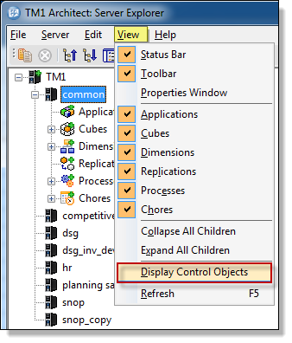

- Expand Cubes and then look for the “}ElementAttributes_yourcubename” (the cube that has the data that you are using to populate your attributes - in this example, Account)

- Right-click on “}ElementAttributes_yourcubename” and then click on Create Rule…

- The “Rules Editor” will appear in which you will be creating Rules to populate your attributes. These rules are very similar to the rules used in the last section.
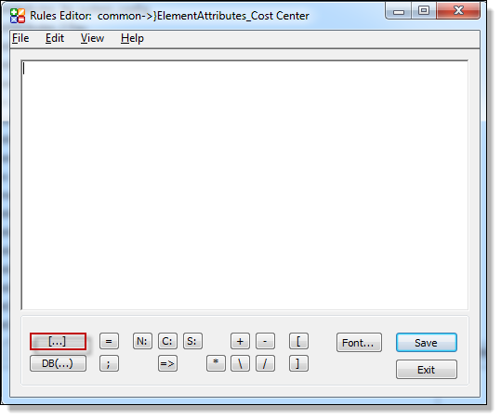

- Click the […] button

- A box will appear with the two dimensions you have available in your cube. We do not want to do anything with the “Account” dimension as we want to include all of our account numbers. We are looking for the columns because we want to choose one of them. Thus, click on }Elementat… (outlined in red)
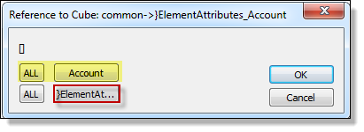

- In the box that appears (which will be all of your column headers), choose the ONE that you want to populate first. In this case, I will choose “BUD Contributor Web Application” Click on it and then click OK
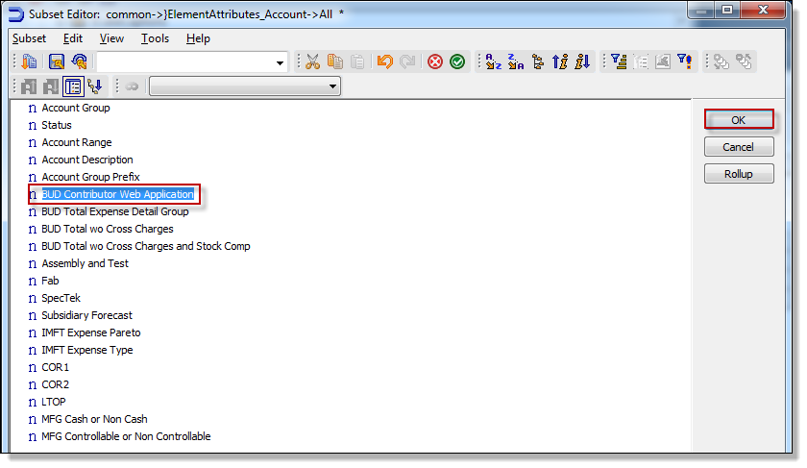

- Click OK on the following pop-up:
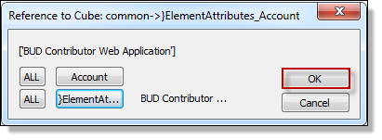

- Click the = button

- Click the S: button (or other appropriate button if not a string)

- Next, you will choose where the data will come from. Click on the DB(…) button and then choose the cube where the data resides (in this case, the data/mappings/attributes reside in the Account cube) and click OK
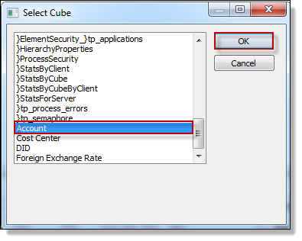

- In the following pop-up, I do not change “Account” because I want all of my accounts to be populated. I choose my other dimension because now I need to match the dimension in the “Account” cube to the one that I am populating attributes. I am populating the “BUD Contributor Web Application” attribute so I want to pull data from the “BUD Contributor Web Application” column in my cube. That is found in the dimension outlined below:
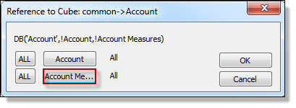

- Highlight the column name by clicking on it and then click OK
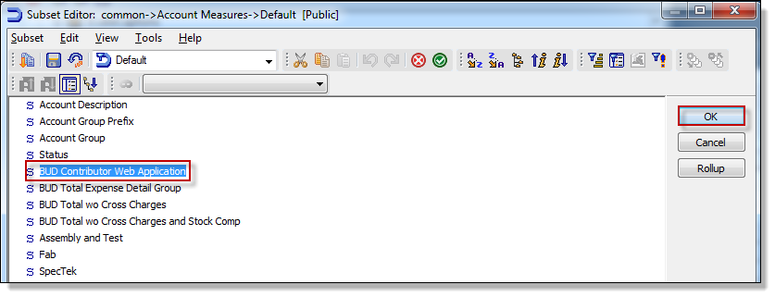

- Click OK on the remaining pop-up:
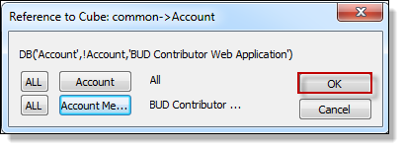

- Click on the ; button

- Hit Enter key to go to the next line

- Do this for every column that you want to publish. The “Account” cube ended up looking like this:
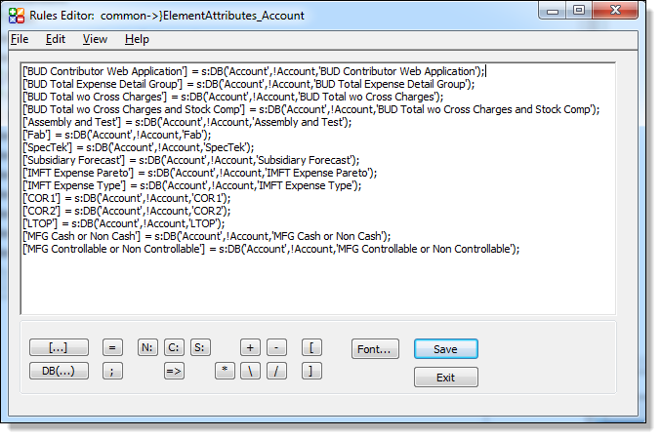

- When done, click Save

- Click Exit

Have table created on SQL server

Finish TI Process

Now that the additional attributes have been added to the “Account” dimension, we need to add them as Variables in our TI process. We’ve already added four (for the first four attributes that were already in the “Account” dimension) but now we need to add all the rest that are from the data portion of our cube.

- Continue adding the attributes like you did in Step 7 of the “Create TI Process” section. For the “Account” cube, it ended up looking like this:
The four original attributes that were already in our “Account” dimension

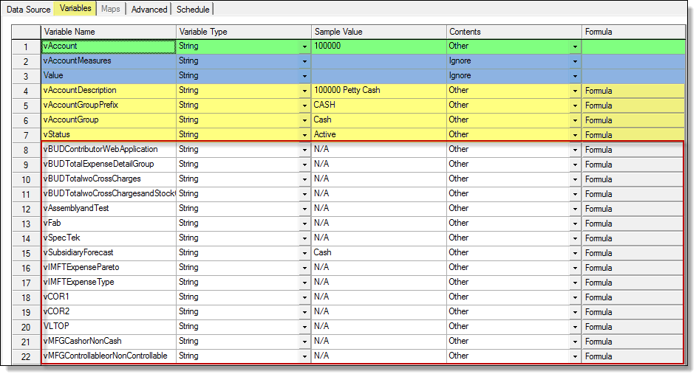

Etc. Additional columns aren’t seen in the screenshot, but are in the cube.
The additional attributes that were added that were columns in our “Account” cube

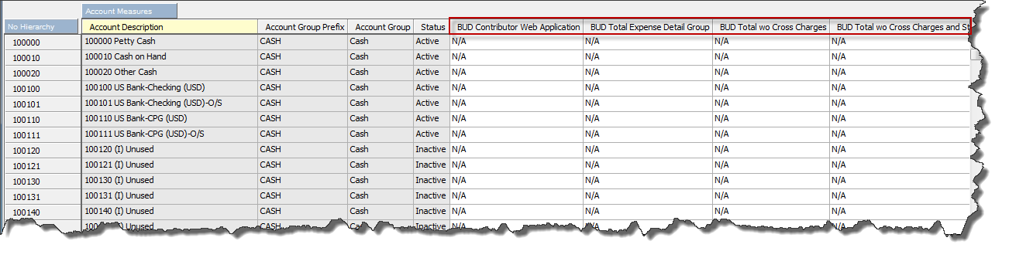

- Now that all the variables are defined, we can add the scripting to the Advanced tabs:

  - Parameters – none

  - Prolog

Note: Red text is syntax you need and blue text is customizable syntax that you change to suit your personal needs.
This line is used to Connect to the server and passes along the credentials that you provide. Use caution as to what username you use. TM1 does not hide the password as is shown here. In TM1, it’s clearly visible.

ODBCOpen(‘SERVERNAME’,’username’,’password’);
ODBCOutPut(‘SERVERNAME’,Expand (‘truncate table database.tablename’));
This line is added to clear out the table on the server prior to publishing. This was needed because a Primary Key was set on Account to allow only unique accounts. Thus, if this wasn’t there, it errors because an account is already listed. But, if it’s cleared out first, when the publish happens, there is a unique account because the table is empty.

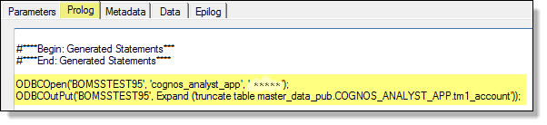

  - Metadata – nothing manually added. Only autogenerated statement will appear

  - Data

ODBCOutPut('SERVERNAME',
Expand ('INSERT INTO database.table
(Account ,
These are the column names exactly as they appear on the table you are publishing to. Only 4 are shown for simplicity, but in reality, there are many more listed – one for each column in the Account cube has a corresponding column in the table on the SQL server it gets published to.
Account_Description ,
Account_Group_Prefix ,
Account_Group ,
Status)
VALUES
(''%vAccount%'' ,
These are the names of the variables you are publishing as seen on the Variables tab in the TI process. VERY IMPORTANT: Those are not double quotes. Those are two single quotes put together. A double quote “ will not work. You must use two ‘ quotes.
''%vAccountDescription%'',
''%vAccountGroupPrefix%'' ,
''%vAccountGroup%'' ,
''%vStatus%'' )'));

  - Epilog

ODBCClose(‘SERVERNAME’);

- Save

Special Note: There was additional syntax that needed to be added in order to Publish the Account cube. There were a couple columns that had an apostrophe ( ‘ ) in the description. Thus, a “loop” needed to be added in order to look for a single apostrophe and replace it with a double apostrophe so the process didn’t fail due to it trying to create two columns out of one (delimiting on the single apostrophe). The additional syntax that was added to the top of the Data tab was:

sAccountDescription = '';
nCounter = Long ( vAccountDescription );
While ( nCounter > 0 );
sCharacter = SubSt ( vAccountDescription, nCounter, 1 );
If ( sCharacter @= '''' );
sCharacter = '''''';
EndIf;
sAccountDescription = sCharacter | sAccountDescription;
nCounter = nCounter - 1;
End;

And, then a slight alteration was made to the other syntax. In the Values section, the “v” in front of “AccountDescription” was changed to an “s” as shown below:

VALUES
(''%vAccount%'' ,
''%sAccountDescription%'',
''%vAccountGroupPrefix%'' ,
''%vAccountGroup%'' ,
''%vStatus%'' )'));

