Implementing accumulation D-Link in TM1 is Possible by adding one extra element in Measures List
which would contain reference of data item which suppose to get accumulated.
For eg.
Source Cube:-
We have one cube which contain Product list, Months & Measures. Measure dimension contains
Product Quantity & Product Category (Pick List- A, B, C) elements
In this cube User will specify the product category & enter the corresponding quantity
Below is the screenshot for Source Cube.
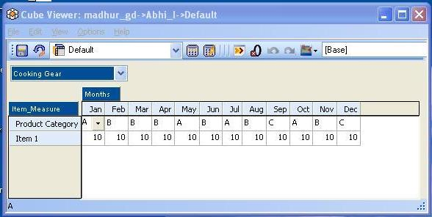

Target Cube before applying Accumulation Rule:-
In Target cube we have Product list, Category (With Category Attribute), Months & Measures.
Measure dimension contains Product Quantity & Product Category
(Without Pick List- A, B, C) elements
Below is the screenshot for Source Cube.
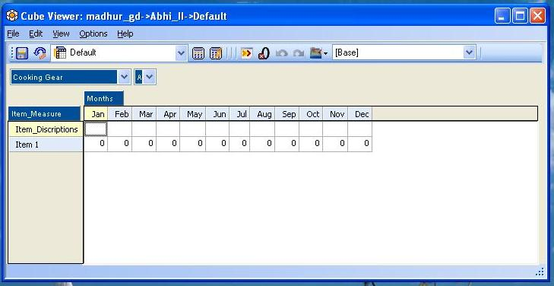

Accumulation Rule:-
Please find below screenshot of Accumulation rule.
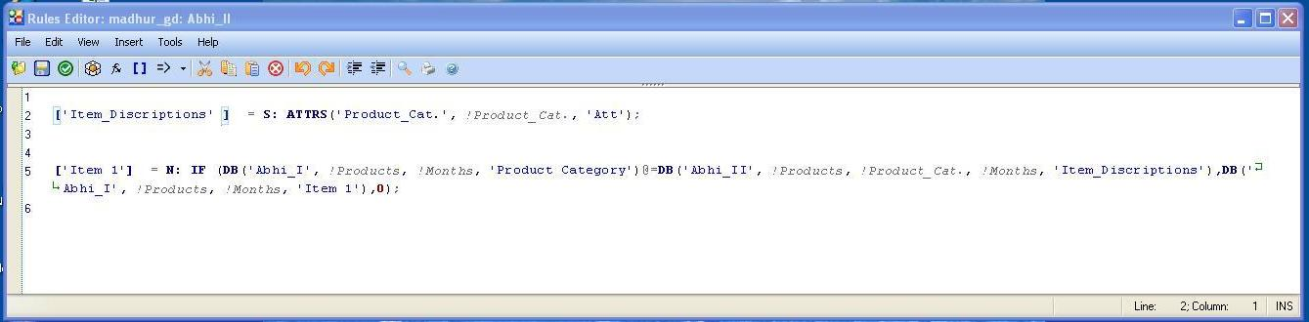
Rule Explanation:
Item_Description measure is pulling Text attribute of Product_Category (A, B, C) dimension which is used for comparing the Product category of Target Cube with product wise category specified in Source Cube.
Item 1 measure is used to pull the Item 1 value from source cube using comparision of Item_Discription & product wise category specified in Source Cube.
Target Cube after applying Accumulation Rule:-
Please find below screenshot of accumulation cube.


